**Kickstarting with Excel**

**Overview & Purpose of Project**:

In an effort to provide additional analysis for the potential of success of the ‘Fever’ production, Kickstarter campaign datasets were pulled and visualized in order to review how other theater/play productions faired based on their launch dates and fundraising goals. Specifically, evaluations were conducted by using a pivot table to look at success/failed/cancelled metrics for theater productions based on month launch dates between the years 2009-2016. Additional analysis was conducted on the sub-category plays and the correlations between success and funding goals. The initial outcomes suggest there are better months than others to launch in a theater, while the relationship between funding goals and play success is murkier.

**Analysis and Challenges:**

Analysis was conducted using a variety of tools in excel including date conversion, percentage, and countif formulas, a variety of filtering tools, and pivot tables. All data was pulled from the Kickstarter spreadsheet. The results were then graphed to further interpret the data in order to more efficiently come to conclusions on determining the success of a given production within our parameters.

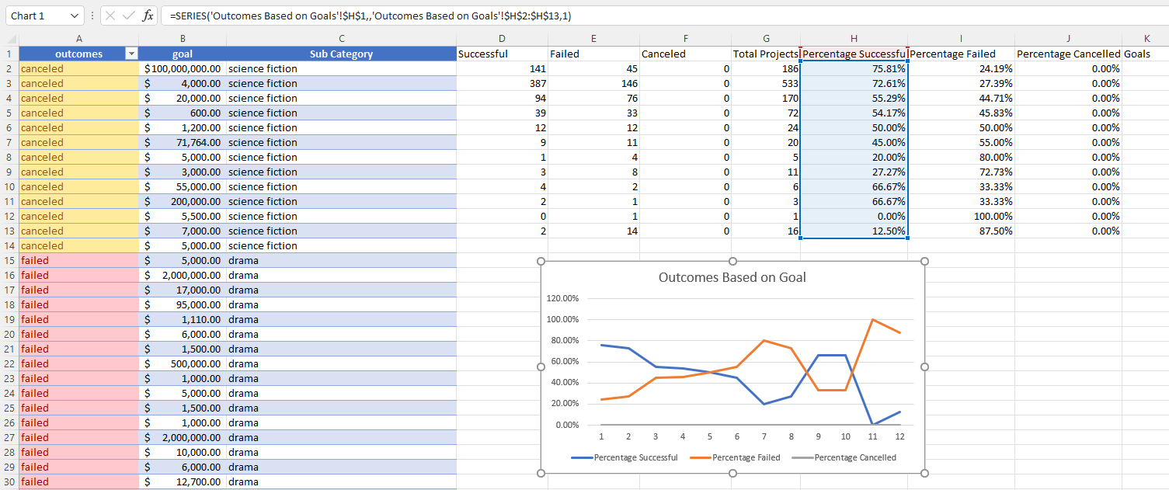

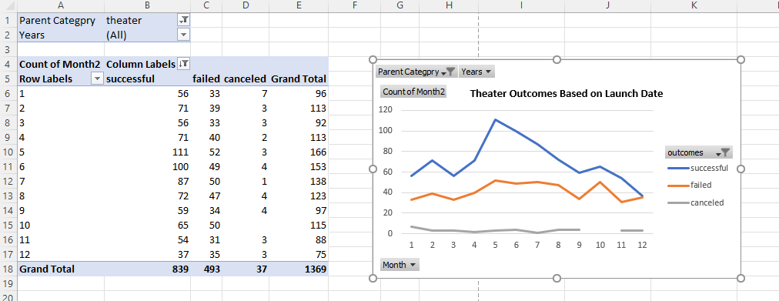

**Challenges**

The main challenged I faced was converting the pivot table to group by month. It seems despite numerous attempts I could not select group on the date field. In order to circumvent this challenge, I added a ‘=month()’ column to the original Kickstarter data sheet to supplement the ‘Year’ column in order to view the data.

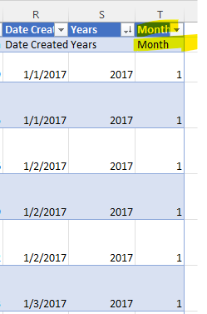

**Results**

**Analysis of Outcomes Based on Launch Date:**

The primary conclusion from the launch date is that there is a noticeable spike in the success of theater productions in the spring and early summer months followed by a steady decline through the end of the year with the exception of slight uptick in the early fall.

Failure rates are more consistent throughout the year ranging from 30-50% despite the season suggesting there are other variables that might better predict the likely failure of a play than launch date.

**Analysis of Outcomes Based on Goals:**

Given the frequent inversion of the percent successful and percent failed data points across funding rages for plays indicates that project funding goals have little influence on the final outcome of a production. The exception to this is plays with $45,000+ of funding goals which are significantly more likely to fail.

**What are some limitations of this dataset?**

This is a fairly robust dataset that could lead to much more analysis than was conducted in this exercise, however, it would likely benefit from more current data than 1/1/2017 as perhaps Kickstarter adoption has increased since that time.

**What are some other possible tables and/or graphs that we could create?**

Additional tables and associated graphs that could potentially benefit our analysis include the measuring outcomes based on pledged money instead of goals, analysis of the development timeline of the play (time between launch date and deadline), success by geography, and finally how the number of backers influences the success of a campaign for a given industry.